EE-111 Linear Circuit Anaylsis
End Semester Project Report

Title: Home Automation System
Type: Voice Controlled
Submitted to: Engr. Ali Khalid

Submitted By:
Group Members | CMS ID
Laveeza Fatima | 515521
Ramisa Irum | 504703
Ayesha Mohsin | 517660
Fatima Habib | 509029

Table of Contents

- Introduction
- Objectives
- System Overview
- Methodology
  - Hardware
  - Software
  - Steps
- Implementation
- Results
- Challenges
- Future Work
- Conclusion
- Team Contribution
- References

1. Introduction
The advent of smart technologies has revolutionized how we interact with everyday objects. This project aims to develop a Voice Controlled Home Automation System, providing an efficient and user-friendly solution for controlling home appliances using voice commands. The system is particularly beneficial for individuals with mobility challenges, enhancing comfort and accessibility.
2. Objectives
- To design a voice-activated system capable of controlling various home appliances.
- To ensure reliability, low power consumption, and seamless integration with existing household devices.
- To improve user convenience and promote sustainable energy usage by avoiding unnecessary appliance operation.
3. System Overview
The system consists of three primary components:
- Voice Recognition Module: This module converts spoken commands into digital signals.
- Control Unit: Processes the signals and triggers the appropriate appliance.
- Appliances: Standard electrical devices connected to the automation system.
The communication between the components is facilitated via Bluetooth.
4. Methodology
Hardware:
- Microcontroller: Arduino Mega.
- Relay modules for appliance switching.
- Bluetooth Module: HC-05.
- Power Supply: DC adapter.
- APP named Arduino Bluetooth Contoller
- Google Assistant for voice input
- LEDs (acting as bulbs), DC Motor (acting as fan), and Servo Motor for door automation.
Software:
- Voice recognition using a compatible smartphone app.
- Programming environment: Arduino IDE.
- Communication protocol: Serial communication via Bluetooth.
Steps:
- Program the microcontroller to interpret voice commands received through the Bluetooth module (HC-05).
- Interface the microcontroller with relay circuits connected to appliances.
- Use relay modules to connect two LEDs simulating light bulbs and a DC motor as a fan.
- Directly connect a servo motor to the Arduino Mega for door automation with 90-degree rotation.
- Implement a control protocol to manage communication between the hardware and the smartphone/voice assistant.
- Test and troubleshoot the system to ensure reliability.
5. Implementation
The project was implemented over four phases:
- Designing the Circuit: Developed schematics integrating the microcontroller, relays, and the power supply.

- Programming the Microcontroller: Wrote and uploaded code for command interpretation and device control.
- System Integration: Connected hardware components and established communication protocols.
- Testing and Optimization: Ensured accuracy in voice command recognition and appliance control.
6. Results
The final system successfully:
- Recognized predefined voice commands.
- Operated connected appliances efficiently without latency.
- Controlled LEDs (bulbs), a DC motor (fan), and a servo motor (door) seamlessly.
- Allowed for additional appliance integration without altering the base design.
- Worked seamlessly within the typical Bluetooth coverage area.
7. Challenges
- Ensuring accurate voice recognition in noisy environments.
- Balancing energy efficiency with the need for active listening by the system.
- Integration with a wide variety of appliance types and models.
8. Future Work
To enhance the system's capabilities, future improvements could include:
- Adding compatibility with more voice assistants and languages.
- Incorporating advanced AI for personalized automation and predictive analytics.
- Implementing robust security protocols to prevent unauthorized access.
9. Conclusion
This Voice Controlled Home Automation System represents a significant step toward smarter and more accessible living spaces. The project achieved its objectives by delivering a functional, reliable, and scalable solution. With further development, it holds immense potential for widespread adoption.
10. Team Contribution
- Hardware Design and Assembly: [Laveeza Fatima & Ramisa Irum]
- Programming and Software Integration: [Fatima Habib & Ayesha Mohsin]
11. Code:
#include <Servo.h>

Servo myservo; // create servo object to control a servo

void setup() {
myservo.attach(9);
myservo.write(0);
Serial.begin(9600); // Start the serial communication
pinMode(2, OUTPUT); // Set pin 2 as an output
pinMode(3, OUTPUT); // Set pin 3 as an output
pinMode(4, OUTPUT); // Set pin 4 as an output
pinMode(5, OUTPUT); // Set pin 5 as an output
digitalWrite(4, LOW); // Initialize LED off
digitalWrite(5, LOW); // Initialize LED off
digitalWrite(2, LOW); // Initialize LED off
digitalWrite(3, LOW); // Initialize LED off
}

String voice;

void loop() {
if (Serial.available() > 0) {
voice = Serial.readString(); // Read the received string
voice.trim(); // Remove any leading/trailing whitespace, \n, \r
Serial.println("Command: " + voice); // Debugging: print the command
}

if (voice == "turn on LED") {
digitalWrite(4, HIGH); // Turn on the LED
digitalWrite(5, HIGH);
Serial.println("LED is ON");
} else if (voice == "turn off LED") {
digitalWrite(4, LOW); // Turn off the LED
digitalWrite(5, LOW);
Serial.println("LED is OFF");
}
else if (voice=="turn on fan"){
digitalWrite(2, HIGH); // Turn on the LED
Serial.println("FAN is ON");
}
else if (voice=="turn off fan"){
digitalWrite(2, LOW); // Turn on the LED
Serial.println("FAN is OFF");
}
else if (voice=="open door"){
myservo.write(90);
Serial.println("DOOR is OPEN");
}
else if (voice=="close door"){
myservo.write(0);
Serial.println("DOOR is close");
}
}

12. Simulations: 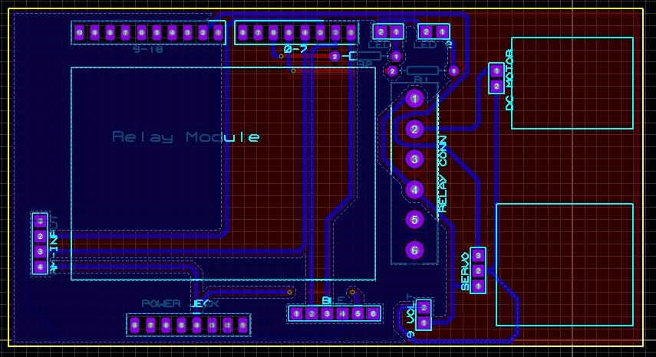

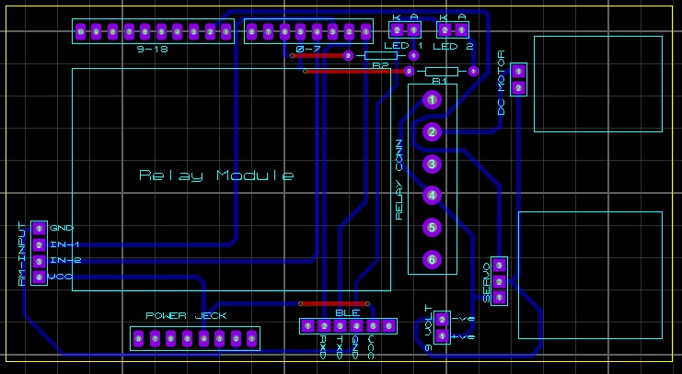

13. Circuit Pictures:
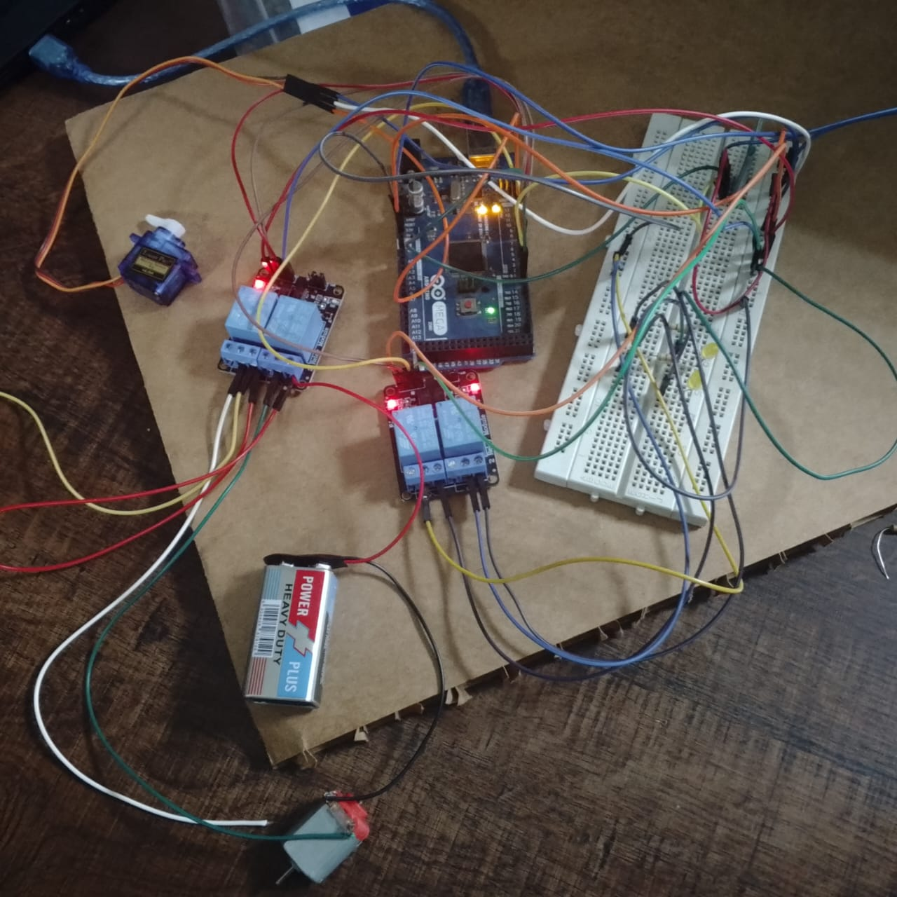

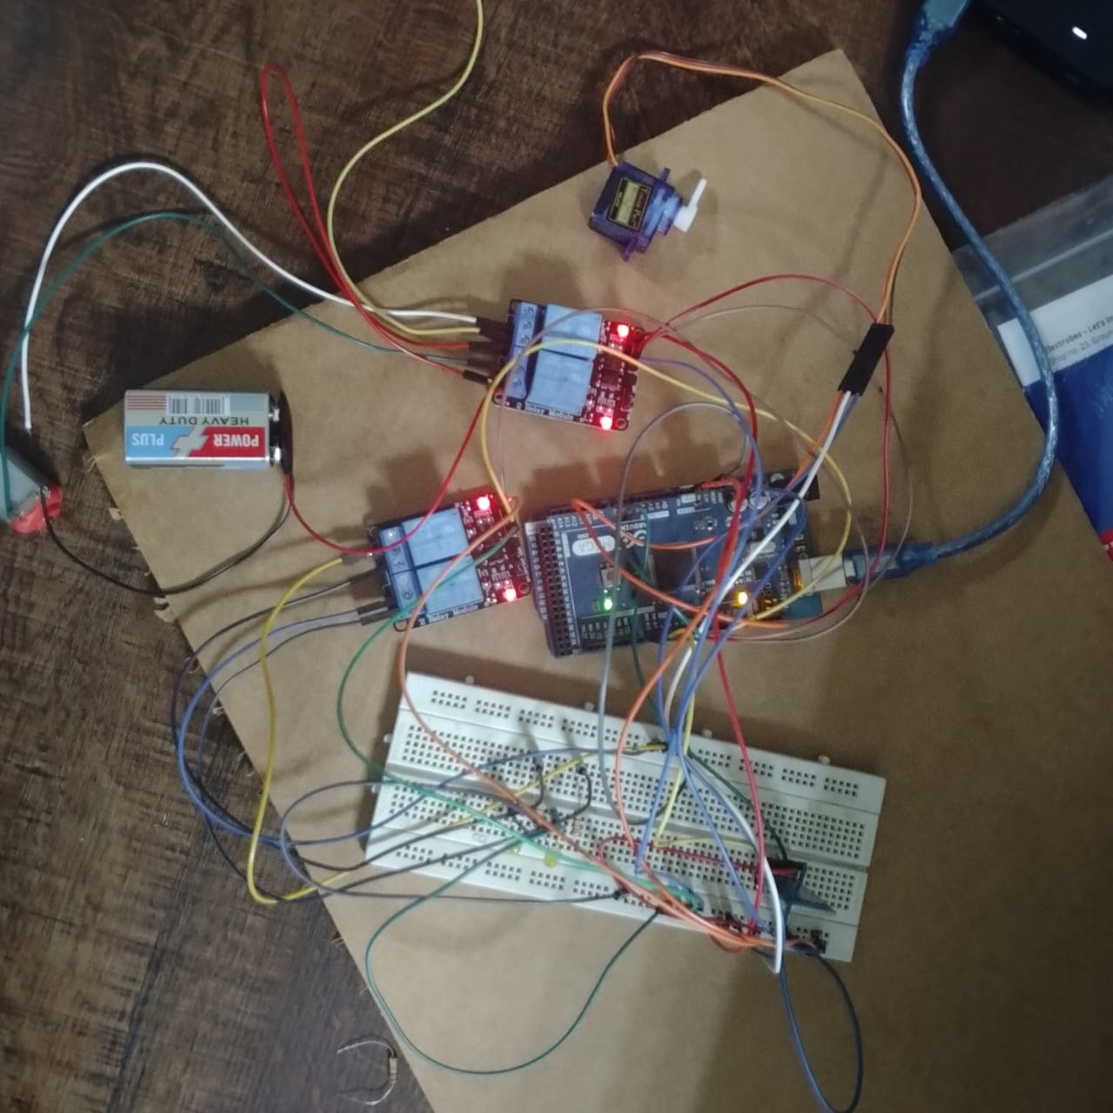

14: References:
- https://youtu.be/HG-W3-bLvpo?si=QKaoeJ4j_i0cfDRa
- https://youtu.be/gpB4600keWA?si=KIIi0BQ_gINl56Dl

